**Supplemental Data**: Data Plotting and Reduction Techniques

A computerized method was developed to accept the actual spectral data taken from the charts, compute and plot the protein-to-starch ratios (corrected for prism baseline shifts) for duplicate daily analyses, and to compute and plot a line through the average values. Where data points were missing, simple arithmetic interpolation was used. Figure S1 is a sample computer plot for the data from one subject's specimens taken daily over a 180 day period.

In an attempt to discern regularities or periodicities in these records, Fourier Transform analyses (power spectrum analyses) were performed as illustrated in Figures S2 and S3, the latter figure simply being a replot with period as the abscissa. From the straight spectral plot (Figure S1) we have visual evidence of "periodicities" of 27.4, 15.5, 8.7, 6.2, and 3.3 days. The most significant component is 27.4 days, which correlates with the well-known cycle of human female fertility. The second most significant peak is probably 8.7 days because of its width. The peak at 6.2 days is all but lost in the noise.

These peaks are all real in the sense they represent periodicities present in the time record. However, this does not mean the periodicities are real in that they can be identified with properties of the human time course. More data need to be included in order to reduce the noise level to allow meaningful behavior to stand out with greater confidence. In line with this, it is necessary to recognize that without both a criterion for statistical confidence and an understanding of the underlying sampling "noise" statistics, questions of the presence or absence of these periodicities cannot be strictly addressed.

In regard to Figure S3, there is an obvious bump at 75-175 days. It was rendered obvious by the distortion resulting in the remapping process. If "degree-of-presence" is to be obtained visually, the spectrum of Figure S2 is the proper one to use. Again, to actually establish the presence of such a long-period component, more data are needed to reduce noise. One way to accomplish this (but not the only way) would be to utilize a number of independent records and average their spectra. Although a long period component may be demonstrated, one still could not distinguish, for example, whether it was a 100 day period or 120 day period. For this, the spectral resolution must be increased, which can only be realized from longer records than those now available.

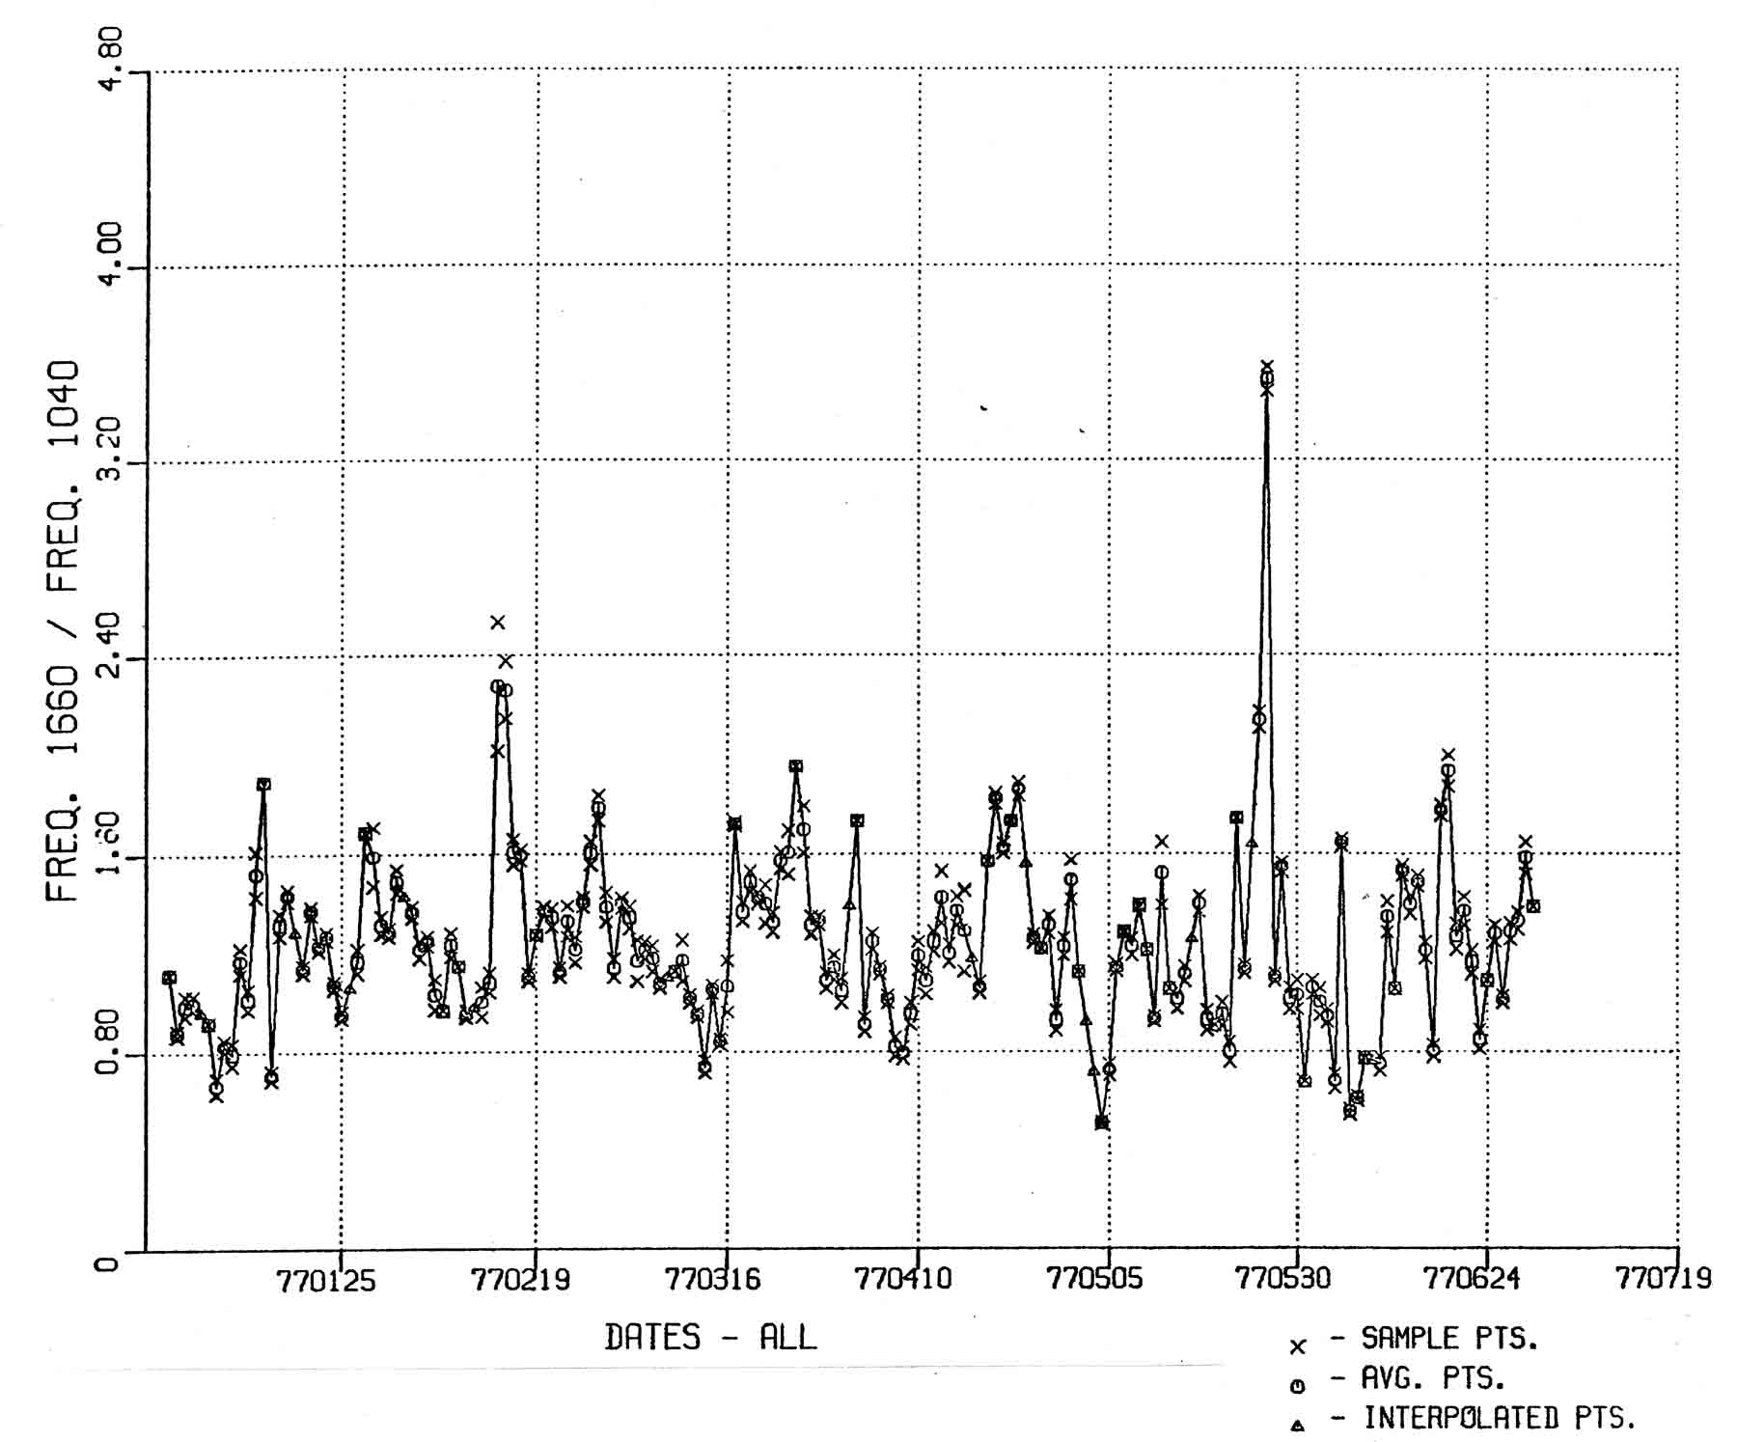

Figure S1 - A computer-produced plot of the IR-based protein-to-starch ratios, using independent measures and averages, for daily samples of vaginal mucin.

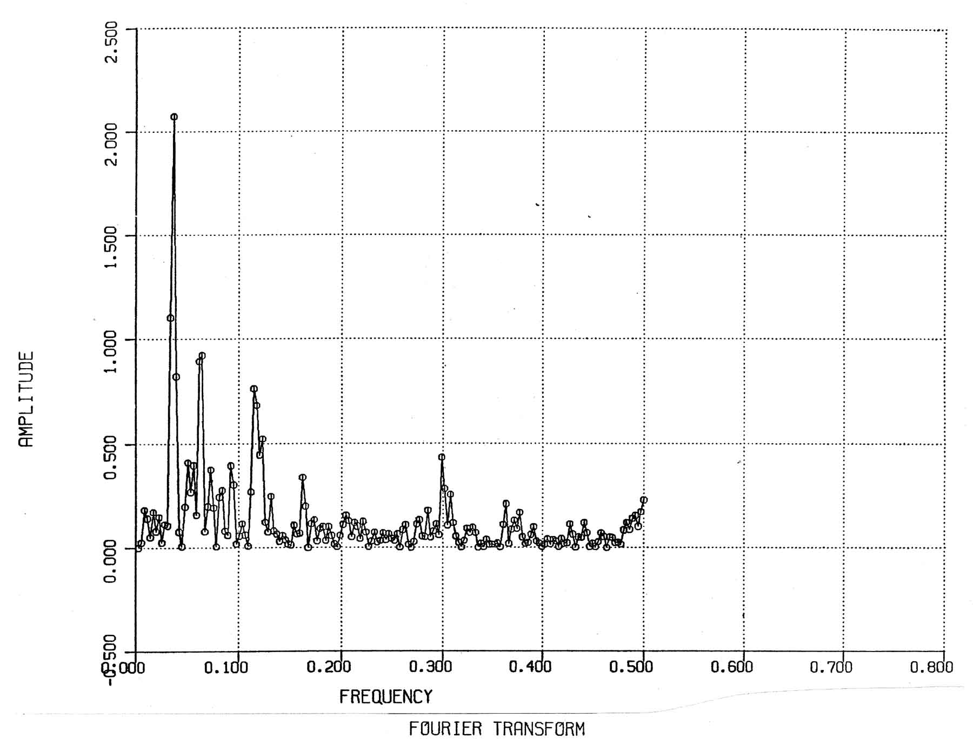

Figure S2 - A “power spectrum” analysis of IR absorptions illustrating the fluctuation of protein-to-starch ratios for daily specimens of vaginal mucin.

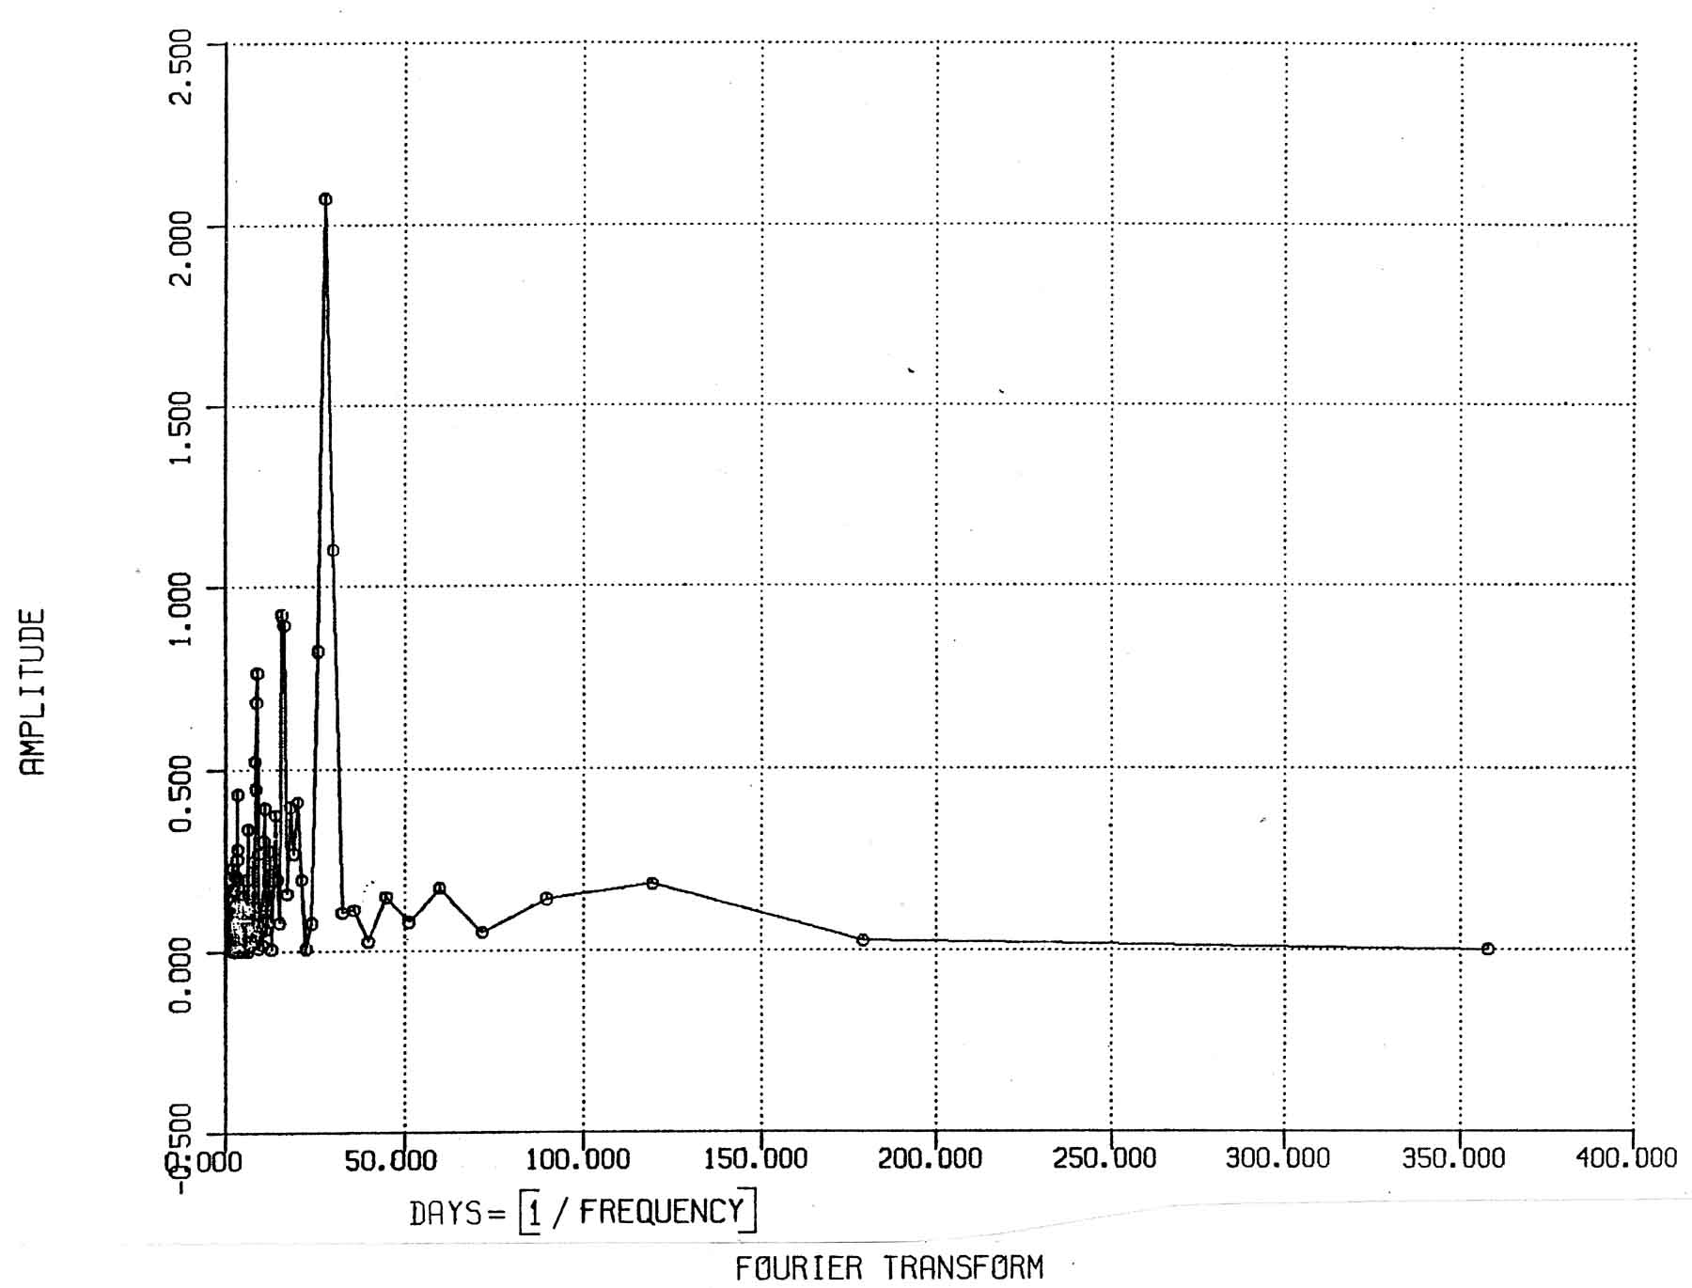

Figure S3 - Additional records of periodicities in daily protein-to-starch ratios for vaginal mucin specimens.